06-June-2018

GENETIC Chooses Artiste DaVinci™ for Morgan Wallen Tour

Creative LED moving head just part of Elation rig for blossoming country artist’s 2018 shows

American country music artist Morgan Wallen is relatively new to the music scene, having released his debut album “If I Know Me” in late April of this year. His star is clearly on the rise however as "Up Down," his lead single from the album, was recently certified gold. Wallen has been on the road since February with an Elation rig that includes the new Artiste DaVinci™, and will be out all summer opening up for Luke Bryan.

Lighting design and event production studio, GENETIC Productions, provided the lighting gear for Wallen’s inaugural headlining tour, “Up Down,” which played dates February 2nd to April 28th across the U.S., including an April 27th performance with Florida Georgia Line on “Jimmy Kimmel Live!” GENETIC's Zac Coren served as lead LD and programmer for the tour, which was designed using Capture Nexum software.

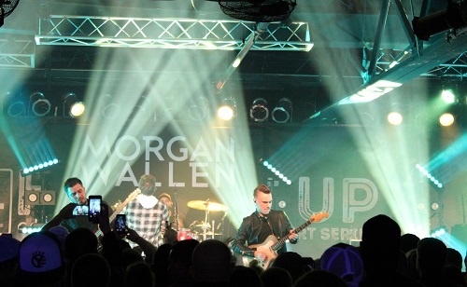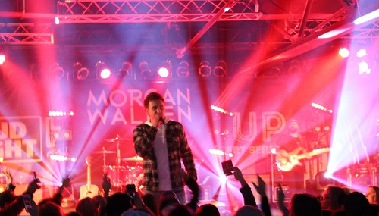

GENETIC, which operates facilities in Philadelphia, Nashville and Washington DC and stocks a variety of Elation product, started working with Wallen towards the end of 2017 in preparation for the 2018 winter tour, a collaboration that resulted in a rig that included Elation’s Artiste DaVinci™ LED moving head spot. “At GENETIC, we do a wide range of events, from corporate meetings and high-end social events to touring, so we needed a fixture that could hold its own in all of those areas, as well as not break the bank,” comments GENETIC President Andrew Sparks, who cites versatility and brightness as reasons for deciding to invest in the Artiste DaVinci. “We have found ourselves quickly and easily replacing the other units we had been using with the DaVinci as it is punchier and has more overall features."

Located behind the band as upstage floor lights, the DaVinci's are used to cast aerial effects as well as provide back light for the band. Lighting designer Zac Coren highlights the fixture’s power and 15 different gobo options as outstanding features. “The DaVinci's have been great by giving many options for creating unique looks for every song,” he said, adding that the fixture has “amazing” output. “Even when stacking a prism, gobo, and animation wheel, I was still surprised with how much output was left. The strong feature set has been nice as well. Having a fully featured spot fixture in such a compact unit has been awesome.” In order to make load-ins/outs quicker and more efficient, the DaVinci fixtures are placed on rolling carts at the base of truss towers.
Coren says one of his favorite looks he was able to achieve with the DaVinci’s was a tunnel look using the cone gobo with a breakup gobo behind it. He then adds that one of the best examples of the DaVinci’s advanced optics is in the song "Whiskey Glasses," where he was able to get a sharp focus on the animation wheel. “It fit the song perfectly,” he said. “Mixed with the CTO flag, I was really happy with how it turned out.”

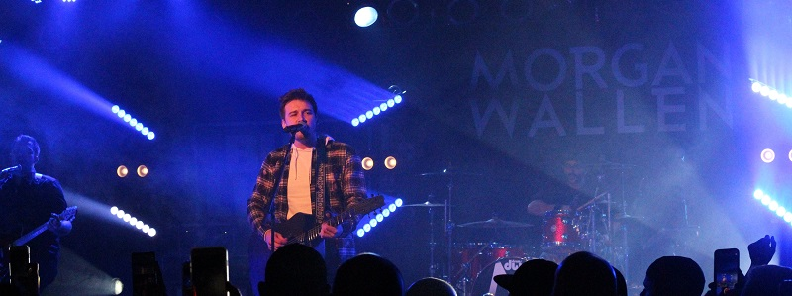
In addition to the DaVinci fixtures, the lighting system includes ACL 360 Bar™ LED moving battens and Cuepix Blinder WW2™ LED-based white light blinders with Arena Par Zoom™ LED Par lights providing side light. It makes for a flexible rig that works in a variety of venues. “The ACL 360 Bars are used for back light as well as giving us a lot of eye candy, making this rig great for both club dates and festival shows,” Coren comments. “We utilized the Cuepix WW2s as a classic country style mole. We bring them in in crucial moments for sing-alongs as well as a few times to get some light on the crowd.”

Andrew Sparks and GENETIC was happy to work with Morgan Wallen and he portends a bright future for the new country music star. “The Morgan Wallen camp has been awesome to work with,” he concludes. “They are a super-friendly group of people that we are proud to be associated with. Big things are coming for all of those involved in the Morgan Wallen camp.”

The “Up Down” tour concluded on April 28th in Las Vegas but the Elation rig is back out with Wallen for the duration of Luke Bryan’s “What Makes You Country” tour, which launched May 31st in Toronto.

About Elation Professional
Elation Professional is one of the world’s leading lighting and visual solutions providers and is the global brand of Elation Lighting. Founded in 1992 and headquartered in Los Angeles, with European sales, distribution and support based in The Netherlands, Elation designs and manufactures a comprehensive range of innovative yet affordable lighting and video products that are distributed through a global network of dealers and distributors. Made up of a spirited team of dedicated personnel, Elation is setting new efficiency and performance standards in Platinum lamp and LED technology and is acknowledged for a comprehensive commitment to Total Support. As a company in expansion with a presence in a growing variety of market segments, chances are you’ve experienced Elation lighting at a concert, special event, TV, theater, late night venue, House of Worship, theme park, cruise ship, exhibition, architectural space or elsewhere. For more information, please visit www.elationlighting.com

For more information, contact:

Elation Professional US
6122 S. Eastern Avenue
Los Angeles, CA 90040
USA
Tel: (866) 245-6726 (toll free)
Tel: (323) 582-3322
sales@elationlighting.com
www.elationlighting.com

Elation Professional EU
Junostraat 2.
6468 EW Kerkrade
The Netherlands
Tel: +31 (0)45 546 85 66
info@elationlighting.eu
www.elationlighting.eu

Elation Professional Mexico
Av Santa Ana 30,
Parque Industrial Lerma,
Lerma, Mexico 52000
Tel: +011 52 728 282 7070
ventas@elationlighting.com
www.elationlighting.com

